**Aim**: Designing Tableau Dashboards for different displays and devices.

**Theory:**

A dashboard is a way of displaying various types of visual data in one place. Usually, a dashboard is intended to convey different, but related information in an easy-to-digest form. And oftentimes, this includes things like key performance indicators (KPI)s or other important business metrics that stakeholders need to see and understand at a glance.

Dataset use here is the **Superstore Dataset** to get the various visual format of the data and create Dashboard of it.

**Steps:**

1. First create the sheet you want to show in the dashboard, for example here in this dashboard there are 3 sheets 1.Trendline 2.Profit_subcategories, 3.Sales_categories.

2. After creating all the sheets, create a dashboard including all the 3 sheets in the dashboard.

3. You can View the dashboard in various mode i.e. Desktop, Mobile, Tablet by clicking on the device type.

**Output:**

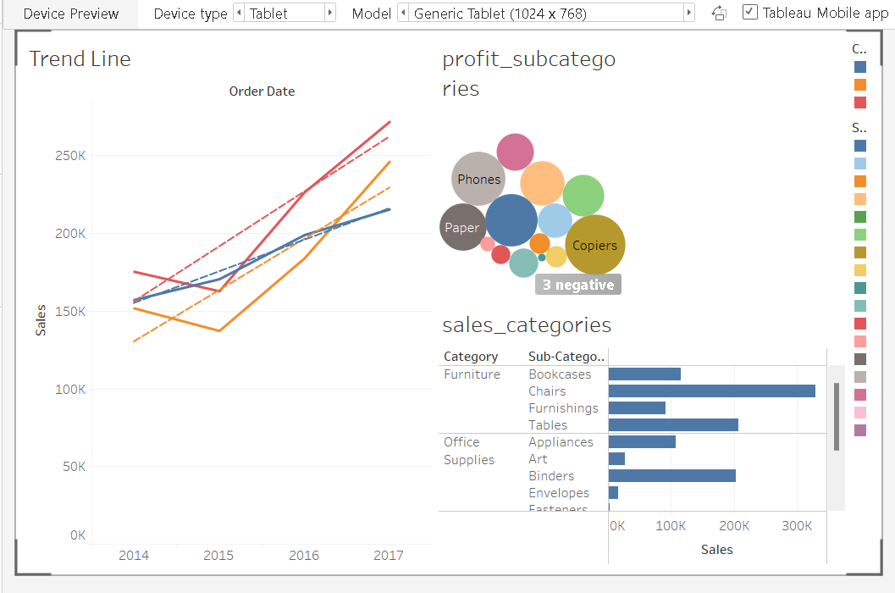

**Result:**

Saw how to create dashboard by using various sheet created just by dragging and dropping the sheet in the dashboard area.